**Rite of Passage Enhancement School Application**

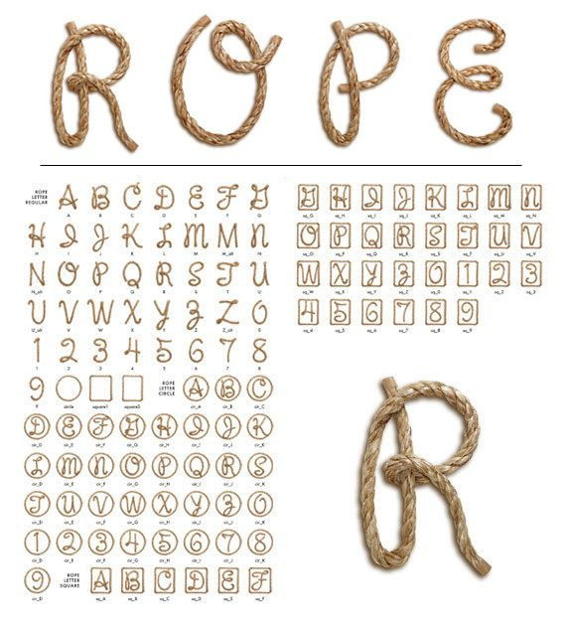MERIDIAN, MISSISSIPPI CAMPUS

**Participant Information**

Name:

Age: Click here to enter text.

Mailing Address: Click here to enter text.

City: Click here to enter text.

State: Click here to enter text.

Zip: Click here to enter text.

Home Phone: Click here to enter text.

Cell Phone: Click here to enter text.

Email: Click here to enter text.

Birthday: Click here to enter text.

Gender: Click here to enter text.

Ethnic Background: Click here to enter text.

Grade: Click here to enter text.

GPA: Click here to enter text.

School: Click here to enter text.

Tee Shirt Size: YS YM YL S M L XL 2X 3X



**Parent Information**

Parent/Guardian Name: Click here to enter text.

Phone: Click here to enter text.

Address: Click here to enter text.

Parent/Guardian Name: Click here to enter text.

Phone: Click here to enter text.

Address: Click here to enter text.

Emergency Contact: Click here to enter text.

Phone: Click here to enter text.

Relationship: Click here to enter text.

Name of Physician: Click here to enter text.

Phone: Click here to enter text.

Insurance Carrier/Plan Name: Click here to enter text.

**Student Academic Achievements/Awards**

Click here to enter text.

**Student Extracurricular Activities**

Click here to enter text.



**Student School Office Referrals** (number and reasons)

Click here to enter text.

**Student Academic Strength**(s)

Click here to enter text.

**Student Academic Weakness**(es)

Click here to enter text.

**Student Interest**(s)

Click here to enter text.

**Reason Why You Are Interested In Attending R.O.P.E.**

Click here to enter text.



**Parent/Guardian Authorization**

I, the undersigned parent/guardian, give permission for the above named to participate in R.O.P.E.S. events. I recognize and acknowledge that youth activities can involve certain hazards, including but not limited to, illness, injury, and accidents, and release R.O.P.E.S. from liability. I hereby certify that the information above is correct. IN CASE OF MEDICAL EMERGENCY, I understand that every effort will be made to notify me or the emergency contact person above. If unable to be reached, I hereby give my permission to the chaperone(s) of the activity to contact my physician, or another physician if the above name medical professional is unavailable. I grant permission to that physician to hospitalize, order injections, administer anesthesia, perform surgery or seek other emergency medical treatment, including ordering x-rays or routine tests, for participant named above. I herby give permission to the designated medical provider to offer routine healthcare and administer all medications, including non-prescription (over-the-counter) drugs. I agree to the release of any records necessary for the insurance purposes, this completed form may be photocopied for trips off of designated property.

Signature of Parent/Guardian: Click here to enter text.

Date: Click here to enter text.

Application Fee $25.00 Enclosed / Submitted Yes/No: Click here to enter text.

**Photo Release**

I understand that while participating in R.O.P.E.S. affiliated events, photographs and videos may be taken of me and/or my child. By signing below, I am acknowledging this and agreeing to allow R.O.P.E.S. to use these photos and/or videos for display and promotion according to all safe media procedures.

Signature of Parent/Guardian: Click here to enter text.

Date: Click here to enter text.

**Transportation Release**

I, the undersigned parent/guardian, give permission for the above named to be transported to and from scheduled off-site youth events by a driver approved by R.O.P.E.S. I understand that one-on-one driving situations will only be permitted with prior permission specific to the given event.

Signature of Parent/Guardian: Click here to enter text.

Date: Click here to enter text.

